

**School of Engineering Technology**

**Main Campus, Off Hennur-Bagalur Main Road, Chagalahatti, Bengaluru-562149**

***PROGRAMMING WITH PYTHON (4BCS105),***

***PROJECT REPORT ON,***

***“AUTOMATIC VISION OBJECT TRACKING”***

Submitted to,

***School Of Engineering and Technology, CMR, Bagalur***

for the partial fulfilment of the Requirement for the Award of the Degree of

***Bachelor of Technology,***

***In,***

***ELECTRONICS AND COMMUNICATION***

Submitted by:

***AISHWARYA-1***(REG.NO :18BBTEC003)

***AKHIL.G-2*(**REG**.**NO **:** 18BBTEC004)

***ABHISHEK.M****(REG.NO : 18BBTEC002)*

***ANUP IVAN(****REG. NO: 18BBTCE014)*

***Under the Guidance Of,***

***Prof. GEETHA***

**CMR UNIVERSITY BAGALUR,**

**2018-19**



**School of Engineering Technology, CMR**

**Main Campus, Off Hennur-Bagalur Main Road, Chagalahatti, Bengaluru-562149**

***CERTIFICATE***

*Certified that the project work entitled* ***AUTOMATIC VISION OBJECT TRACKING*** *carried out by Mr./Ms.* ***AISHWARYA(*** *REG.NO* ***18BBTECOO3******), AKHIL.G(*** *REG.NO* ***18BBTEC004), ABHISHEK.M (REG.NO 18BBTEC002), ANUP IVAN (****REG****.****NO****18BBTCE014****)* ***in*** *partial fulfilment for the award of Bachelor of Technology in* ***ELECTRONICS AND COMMUNICATION ENGINEERING*** *of the CMR University,  Bagalur during the year 2018-19. It is certified that all corrections/suggestions indicated for Internal Assessment have been incorporated in the Report deposited in the departmental library. The project report has been approved as it satisfies the academic requirements in respect of Project work prescribed for the said Degree.*

***Name of the Guide Name of the Dean***

*Signature of the Guide                     Signature of the Dean*

**Examiners**

**Name of the examiners Signature with date  
1  
2**

***DECLARATION***

*We,* **AISHWARYA*,* AKHIL.G*,* ABHISHEK.M, ANUP IVAN***students of CMR university school of engineering and technology, bagalur hereby declare that the dissertation entitled* ***“*AUTOMATIC VISION OBJECT TRACKING *”*** *embodies the report of my project carried out independently by me during first semester of* ***Bachelor of Engineering in* electronics and communication*,*** *under the supervision and guidance of* ***Prof.* GEETHA*,*** *Department of Computer Science and Engineering and this work has been submitted for the partial fulfilment of the requirements for the award of the* ***Bachelor of Engineering*** *degree.*

*We have not submitted the matter embodies to any other university or institution for the award of other degree.*

*Date: 18 December 2018*

*Place: Bangalore* **AISHWARYA (18BBTEC003)**

SIGNATURE OF STUDENT-1

**AKHIL.G (18BBTEC004)**

SIGNATURE OF STUDENT-2

**ABHISHEK.M (18BBTEC002)**

SIGNATURE OF STUDENT **-**3

**ANUP IVAN (18BBTCE014)**

SIGNATURE OF STUDENT -4

***ACKNOWLEDGEMENT***

*We express our foremost gratitude to* ***Dr. Name on dean****, Dean for his constant support.*

*We express our foremost gratitude to my guide* ***Prof .GEETHA****, Dept. of Computer Science & Engineering, CMR University, Bagalur for his/her inspiration, adroit guidance, constant supervision, direction and discussions in successful completion of this dissertation.*

*Our sincere thanks to all teaching and non-Teaching Staff of* ***Computer Science & Engineering Department*** *for all the facilities provided, without which, We could not have progressed with my work. Thanks to our parents who have been a great source of strength in the completion of this dissertation.*

**AISHWARYA -1**

**(18BBTEC003)**

***AKHIL.G -2***

**(18BBTEC004)**

**ABHISHEK.M -3**

***(18BBTEC002)***

***ANUP IVAN -4***

***(18BBTCE014)***

**ABSTRACT**

The on-going research on object tracking in video sequences has attracted many researchers. Detecting the objects in the video and tracking its motion to identify its characteristics has been emerging as a demanding research area in the domain of image processing and computer vision. This paper proposes a literature review on the state of the art tracking methods, categorize them into different categories, and then identify useful tracking methods. Most of the methods include object segmentation using background subtraction. The tracking strategies use different methodologies like Mean-shift, Kalman filter, Particle filter etc. The performance of the tracking methods vary with respect to background information. In this survey, we have discussed the feature descriptors that are used in tracking to describe the appearance of objects which are being tracked as well as object detection techniques. In this survey, we have classified the tracking methods into three groups, and a providing a detailed description of representative methods in each group, and find out their positive and negative aspects.

**TABLE OF CONTENTS**

#### TITLE PAGE NO

DECLARATION …………………………………………………….…….…………... i

ACKNOWLEDGEMENT ……………………………………………….…….…………..ii

ABSTRACT …………………………………………………………….……………...….iii

TABLE OF CONTENT …………………………………………………..………………..iv

LIST OF TABLES ………………………………………………………….………………v

LIST OF FIGURES …………………………………………………………..………….....vi

CHAPTER

1. TITLE OF THE FIRST CHAPTER .……………………………………………1

First Level Subhead Of First Chapter …………………………….…………#

Second Level Subhead Of First Chapter ……………………………………#

Third Level Subhead Of First Chapter ………………………………...……#

1. TITLE OF THE SECOND CHAPTER .…………………………………..……#

First Level Subhead Of Second Chapter ……………………………………#

Second Level Subhead Of Second Chapter …………………………………#

1. TITLE OF THE SECOND CHAPTER .……………………………………...…#

First Level Subhead Of Third Chapter …………………………………...…#

Second Level Subhead Of Third Chapter ……………………………………#

Third Level Subhead Of Third Chapter ………………………………...……#

EXPERIMENTS AND RESULTS …………………………………………….…..………….#

CONCLUSIONS ………………………………………………………………………..…….#

APPENDICES ………………………………………………………………………………..#

REFERENCES ………………………………………………………………………...#

**LIST OF TABLE**

|  |  |
| --- | --- |
| **TABLE NO TITLE** | **PAGE NO** |
| Table 1.1 Name of First Table | 2 |
| Table 1.2 Name of Second Table | 4 |
| Table 1.3 Name of First Table | 5 |
| Table 1.4 Name of First Table | 7 |
| Table 1.5 Name of First Table | 10 |
| Table 1.6 Name of First Table | 14 |

**LIST OF FIGURES**

|  |  |
| --- | --- |
| **FIGURE NO TITLE** | **PAGE NO** |
| Fig 1.1 Name of First Figure | 3 |
| Fig 1.2 Name of Second Figure | 4 |
| Fig 1.3 Name of First Figure | 5 |
| Fig 1.4 Name of First Figure | 7 |
| Fig 1.5 Name of First Figure | 10 |
| Fig 1.6 Name of First Figure | 14 |

**CHAPTER 1**

**PREAMBLE**

**1.1 Introduction**

Tracking objects in video sequences of surveillance camera is nowadays a demanding application. Tracking objects is much more challenging in video sequences to improve recognition and tracking performances. There are many existing methods of object tracking but all has some drawbacks. Some of the existing models for object tracking are contour-based models, region-based models and feature point-based models. A. Contour-based object tracking model Active contour model is used for finding object outline from an image [1]. In the contour-based tracking algorithm, the objects are tracked by considering their outlines as boundary contours. Thereafter these contours are updated dynamically in successive frames. The discrete version of this approach is represented in active contour model. The discrete version of this approach takes the advantage of the point distribution model to limit the shape. However, this algorithm is highly sensitive to the initialization of tracking, making it difficult to start tracking automatically. B. Region-based object tracking model the region based object model bases it’s tracking of objects on the colour distribution of the tracked object [2, 3]. It represents the object based on the colour. Hence, it is computationally efficient. However, its efficiency is degraded when several objects move together in the image sequences. It is not possible to achieve accurate tracking when multiple objects move due to occlusion. Also, in the absence of any object shape information, the object tracking is largely dependent on the background model used in the extraction of the object outlines. C. Feature point based tracking algorithm In Feature point based model feature points is used to describe the objects [4, 5]. There are three basic steps in feature point based tracking algorithm. The first step is to recognize and track the object by extracting elements. The second step is to cluster them into higher level features. The last step is to match these extracted features between images in successive frames. Feature extraction and feature correspondence are the important steps of feature based object tracking. The challenging problem in feature point based tracking is feature correspondence because a feature point in one image may have many similar points in another image, and hence results in feature correspondence ambiguity.

**1.2 Literature Survey**

**A**.**CONTOUR** **BASED OBJECT TRACKING:** Xu and Ahuja [6] proposed a contour based object tracking algorithm to track object contours in video sequences. In their algorithm, they segmented the active contour using the graph-cut image segmentation method. The resulting contour of the previous frame is taken as initialization in each frame. New object contour is found out with the help of intensity information of current frame and difference of current frame and the previous frame. Dokladal et al.[7] the proposed approach is active contour based object tracking. For the driver’s-face tracking problem they used the combination of feature-weighted gradient and contours of the object. In the segmentation step they computed the gradient of an image. They proposed a gradient-based attraction field for object tracking

**B**.**FEATURE** **BASED** **OBJECT** **TRACKING**: Li et al. [14] proposed a corner feature based object tracking method using Adaptive Kalman Filter. To represent moving object corner feature are firstly used. Then, the number of corner point variation across consecutive frames to is used to automatically adjust the estimate parameters of Kalman Filter

**Color** **features**: To increase the discriminative power of intensity based descriptors color feature descriptors are used [43]. Two physical factors primarily influenced the apparent color of an object- 1) the spectral power distribution of the illuminant and 2) object’s surface reflectance property. To describe the color information of an object RGB color space is usually

used. But RGB color space is not a perceptually uniform color space.

Segmentation Based Segmentation based algorithms are used to segment the image frame into segments to find out the objects of interest. Criteria for good partition and efficient partitioning method plays important role in segmentation algorithms. Later on the segmented objects are considered for tracking.

**C.** **REGION** **BASED** **OBJECT** **TRACKING**: Xu et al.[33] presented a new method for supervised object segmentation in video sequence. In the proposed method the user input object outline is considered as video object. In moving object tracking, the model incorporated the object's region segmentation and the motion estimation. Active contour model is also employed for contour fine-tuning.

**D**.**OBJECT** **DETECTION** 1. Segmentation Based Segmentation based algorithms are used to segment the image frame into segments to find out the objects of interest. Criteria for good partition and efficient partitioning method plays important role in segmentation algorithms. Later on the segmented objects are considered for tracking.

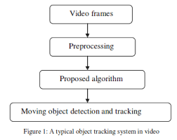

**1.3 Problem statement**

Object Tracking After the object detection is achieved, the problem of establishing a correspondence between object masks in consecutive frames should arise. Obtaining the correct track information is crucial for subsequent actions, such as object identification and activity recognition. For this situation, block matching technique is used.

Tracking Method the tracking method used in this article can be described as following. The matching process is illustrated in Fig.2.6. Firstly, blocks and the tracking area are made only in the area of moving object to reduce the processing time. The previous frame is devided into block size (block A) with 9x9 pixels in the previous frame. It is assume that the object coming firstly will be tracked as the interest moving object. The block A will search the matching block in each block of the current frame by using correlation value as expresses in Eq.(2.5). In the current frame, the interest moving object is tracked when the object has maximum number of matching blocks

**1.4** **Objective**

The importance of an object tracker is that it finds out the motion trajectory of an object as video frames progresses along with time by identifying the object position in every frame of the video. The complete region that is occupied by the object in the image at every time instant can also be found out by the object tracker. The detected objects in frames are being tracked in the subsequent frames. The object detection task and object correspondence establishment task between the instances of the object across frames can be done separately or jointly. In the first scenario, with the help of object detection algorithm possible object regions in every frame are obtained, and objects correspondence across frames is performed by object tracker. In the latter scenario, information obtained from previous frames helps in finding the the object region and correct estimation of correspondence is done jointly by iterative updating of object region and its location.

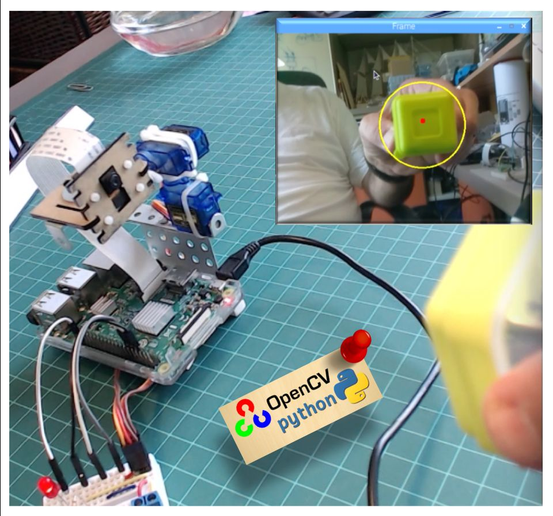

**CHAPTER 2**

**1.5 Methodology**

Tracking can be defined as the problem of approximating the path of an object in the image plane as it moves around a scene. The purpose of an object tracking is to generate the route for an object above time by finding its position in every single frame of the video [5]. Object is tracked for object extraction, object recognition and tracking, and decisions about activities. According to paper [10], Object tracking can be classified as point tracking, kernel based tracking and silhouette based tracking. For illustration, the point trackers involve detection in every frame; while geometric area or kernel based tracking or contours-based tracking require detection only when the object first appears in the scene.

The process of automatic tracking of objects begins with the identification of moving objects of interest in the video sequence and to cluster pixels of these objects. Hu et al. [8] offer a very useful survey of the entire process of automated video surveillance and the techniques involved. While color- and edge-based methods can be used to cluster regions on an image by image basis, surveillance video offers an additional temporal dimension that can be exploited to segment regions of interest in the sequence. Since moving objects are typically the primary source of information in surveillance video, most methods focus on the detection of such objects.

Once moving regions have been identified, the next task is to generate tracks of these objects over successive frames. This is essentially a correspondence task, the goal of which is to find a match for each blob or track in the previous frame to one of the blobs or objects in the current frame.

These methods have the disadvantages of having to develop a model of the object being tracked, and of complicated filter initialization and update procedures for tracking. Our system uses motion as the basis for object segmentation and tracking.

Some of the existing automatic tracking systems discussed often in literature are VSAM [31], W4 [32], and Bramble [33]. VSAM [31] uses a statistical model for the background based on the average and deviation in intensity values at each pixel. A connected components approach is used to segment targets. The objects are tracked based on frame-to-frame matching of blobs using their position, velocity, appearance, size, and colour histogram characteristics. Our system is most similar to VSAM. Both systems are designed to track subjects in outdoor videos using a static camera, and they do so using somewhat similar segmentation and tracking methods. However, we also focus on the problem of depth variation of objects as they move through the scene. Our Bayesian approach for probabilistic track assignment is another significant addition.

**CHAPTER 3**

**GENERAL ASPECTS AND TECHNOLOGY**

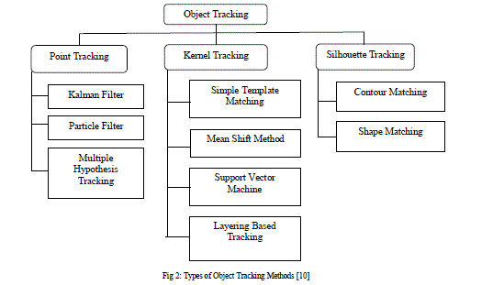

1. **Point** **Tracking:** In an image structure, moving objects are represented by their feature points during tracking. Point tracking [10] is a complex problem particularly in the incidence of occlusions, false detections of object. Recognition can be done relatively simple, by thresh holding, at of identification of these points.

**1.Kalman** **Filter:** They are based on Optimal Recursive Data Processing Algorithm. The Kalman Filter performs the restrictive probability density propagation.

**2**. **Particle** **Filtering**: The particle filtering [10] generates all the models for one variable before moving to the next variable. Algorithm has an advantage when variables are generated dynamically and there can be unboundedly numerous variables.

**3**. **Multiple** **Hypothesis** **Tracking** (**MHT**): In MHT algorithm [10], several frames have been observed for better tracking outcomes MHT is an iterative algorithm. Iteration begins with a set of existing track hypotheses.

**B**. **Kernel** **Based** **Tracking** **Kernel** **tracking** [9] is usually performed by computing the moving object, which is represented by a embryonic object region, from one frame to the next. The object motion is usually in the form of parametric motion such as translation, conformal, affine, etc. These algorithms diverge in terms of the presence representation used, the number of objects tracked, and the method used for approximation the object

Motion is usually in the form of parametric motion such as translation, conformal, affine, etc. These algorithms diverge in terms of the presence representation used, the number of objects tracked, and the method used for approximation the object motion.

1. **Simple** **Template** **Matching:** Template matching [9][4] is a brute force method of examining the Region of Interest in the video. In template matching, a reference image is verified with the frame that is separated from the video. Tracking can be done for single object in the video and overlapping of object is done partially.
2. **Mean** **Shift** **Method:** Mean-shift tracking tries to find the area of a video frame that is locally most similar to a previously initialized model. The image region to be tracked is represented by a histogram. A gradient ascent procedure is used to move the tracker to the location that maximizes a similarity score between the model and the current image region.
3. **Support** **Vector** **Machine**: (SVM) SVM [13] is a broad classification method which gives a set of positive and negative training values. For SVM, the positive samples contain tracked image object, and the negative samples consist of all remaining things that are not tracked. It can handle single image, partial occlusion of object but necessity of a physical initialization and necessity of training.
4. **Layering** **based** **tracking**: This is another method of kernel based tracking where multiple objects are tracked. Each layer consists of shape representation (ellipse), motion such as translation and rotation, and layer appearance, based on intensity. Layering is achieved by first compensating the background motion such that the object’s motion can be estimated from the rewarded image by means of 2D parametric motion.
5. **Silhouette** **Based** **Tracking**: Approach Some object will have complex shape such as hand, fingers, shoulders that cannot be well defined by simple geometric shapes. Silhouette based methods [9] afford an accurate shape description for the objects. The aim of a silhouette-based object tracking is to find the object region in every frame by means of an object model generated by the previous frames. Capable of dealing with variety of object shapes, Occlusion and object split and merge.
6. **Contour** **Tracking** **Contour** tracking methods [9], iteratively progress a primary contour in the previous frame to its new position in the current frame. This contour progress requires that certain amount of the object in the current frame overlay with the object region in the previous frame.
7. **Shape** **Matching**: These approaches examine for the object model in the existing frame. Shape matching performance is similar to the template based tracking in kernel approach. Another approach to Shape matching [10] is to find matching silhouettes detected in two successive frames. Silhouette matching, can be considered similar to point matching.

**CHAPTER 3**

**SYSTEM SPECIFICATION AND DESIGN**

An image sequence captured by a still camera is the input to the system. We first perform Motion Segmentation to extract moving blobs in the current frame. Some blobs that are very small and are likely to be noise are deleted. Due to partial occlusion, some moving objects get incorrectly segmented into two or more separate blobs. Using color and position information, such blobs are merged. The Object Tracking module tracks these moving objects over successive frames to generate Object Tracks.

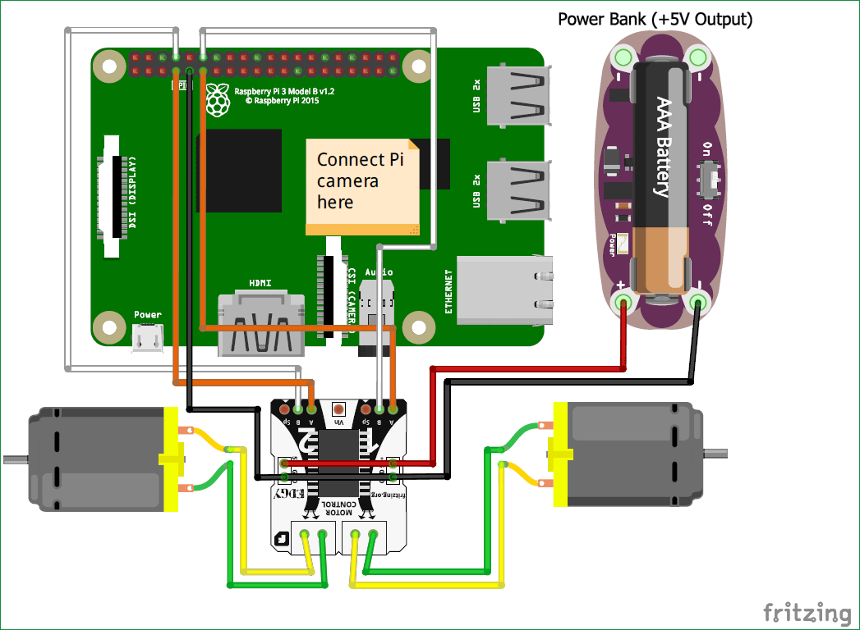

Most pixels in the frame belong to the background and static regions, and suitable algorithms are needed to detect individual targets in the scene. Since motion is the key indicator of target presence in surveillance videos, motion-based segmentation schemes are widely used. We utilize an effective yet simple method for approximating the background that enables the detection of individual moving objects in video frames.

Segmentation using moving average background model A standard approach for finding moving objects in still-camera video data is to create a model for the background and compare that model with the frame in question to decide which pixels are likely to be the foreground (moving objects) and which the background. There are various methods for developing background models.

Enhanced segmentation using a Secondary Background model It was observed that the intensity level of a background pixel changes very little from frame to frame. The value of the background in the previous frame is actually a better estimate of the background in the current frame than is the average value over N frames. To take advantage of this, we use a secondary model of the background (called Secondary Background) which is the actual intensity.

Multiple human object tracking approach is used which based on motion estimation and detection, background subtraction, shadow removal and occlusion detection. Video sequences have been captured in the laboratory and tested with the proposed algorithm. The algorithm works efficiently in the event of occlusion in the video sequences. In paper a tracking algorithm based on adaptive background subtraction about the video detecting and tracking moving objects is presented in this paper. Firstly, median filter is used to achieve the background image of the video and denoise the sequence of video. Then adaptive background subtraction algorithm is used to detect and track the moving objects. The simulation results by MATLAB show that the adaptive background subtraction is useful in both detecting and tracking moving objects, and background subtraction algorithm runs more quickly. Paper attempts to find moving objects by subtracting the background images from static single camera video sequences in security systems. It aims to improve the background subtraction techniques for indoor video surveillance applications. The novel automatic threshold updating (ATU) algorithm is also developed and tested for various indoor video sequences which give better efficiency. The statistical and temporal differencing methods are also presented. Finally, novel approach is compared with the existing methods. Paper presents a new algorithm for detecting moving objects from a static background scene to detect moving object based on background subtraction. Reliable background updating model is set up based on statistical. After that, morphological filtering is initiated to remove the noise and solve the background interruption difficulty. At last, contour projection analysis is combined with the shape analysis to remove the effect of shadow; the moving human bodies are accurately and reliably detected. The experiment results show that the proposed method runs rapidly, exactly and fits for the concurrent detection.

**CHAPTER 4**

**IMPLEMENTATION**

[OpenCV](https://opencv.org/) is free for both academic and commercial use. It has C++, C, Python and Java interfaces and supports Windows, Linux, Mac OS, iOS and, Android. On my series of OpenCV tutorials, we will be focusing on Raspberry Pi (so, Raspbian as OS) and Python. OpenCV was designed for computational efficiency and with a strong focus on real-time applications. So, it's perfect for Physical computing projects!

**STEP** 1:

**MAIN PARTS:**

1. [Raspberry Pi V3](http://a.co/cSjzJhj)
2. 5 megapixel 1080p sensor OV5647 mini camera video module.
3. TowerPro SG90 9G 180 degrees Mini Servo.
4. Mini pan/ Tilt Camera Platform Anti-Vibration Camera Mount w/2 Servo.
5. Led Red.
6. Resistor 220 ohms.
7. Miscellaneous: metal part, bands, etc.

**STEP 2:**

**INSTALLING OPEN CV PACKAGE:**



**OpenCV** is built to provide a common infrastructure for computer vision applications and to accelerate the use of machine perception in the commercial products. **OpenCV** (Open Source Computer Vision) is a library of programming functions mainly aimed at real-time computer vision.

**STEP 2:**

**TESTING THE CAMERA:**

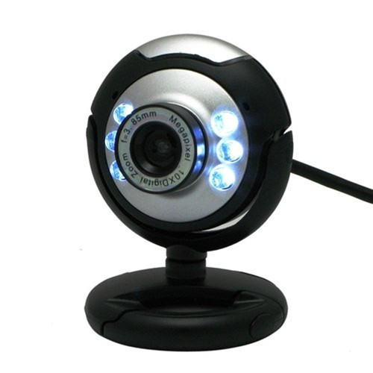

We enter the python code to check the working of the camera

import numpy as np

import cv2

cap = cv2.VideoCapture(0)

while(True):

ret, frame = cap.read()

frame = cv2.flip(frame, -1) # Flip camera vertically

gray = cv2.cvtColor(frame, cv2.COLOR_BGR2GRAY)

cv2.imshow('frame', frame)

cv2.imshow('gray', gray)

if cv2.waitKey(1) & 0xFF == ord('q'):

break

cap.release()

cv2.destroyAllWindows()

the above code will capture the video stream that will be generated by picam, diplay it both, in BGR colour and gray mode.

**To execute, enter the command:**

python simpleCamTest.py

**STEP 5: OBJECT MOVEMENT TRACKING:**

The imutils library installed. It is Adrian’s collection of Open CV convenience functions to make a few basic tasks (like resizing or flip screen ) much easier. We enter the below command to install the library on virtual Python environment:

pip install imutils

we download the code ball tracking.py and execute it using the command:

python ball_traking.py

we use the “video vertical flip” for the rotation of the camera:

frame = imutils.rotate(frame, angle=180)

**STEP 6: TESTING THE GPIO’S :**

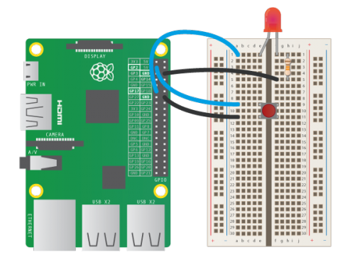

This code will receive as arguments a GPIO number and the frequency in second that the LED should blink. The will blink and the program will be terminated.

python LED_simple_test.py 21 1

**STEP 7: PAN TILT MECHANISM:**

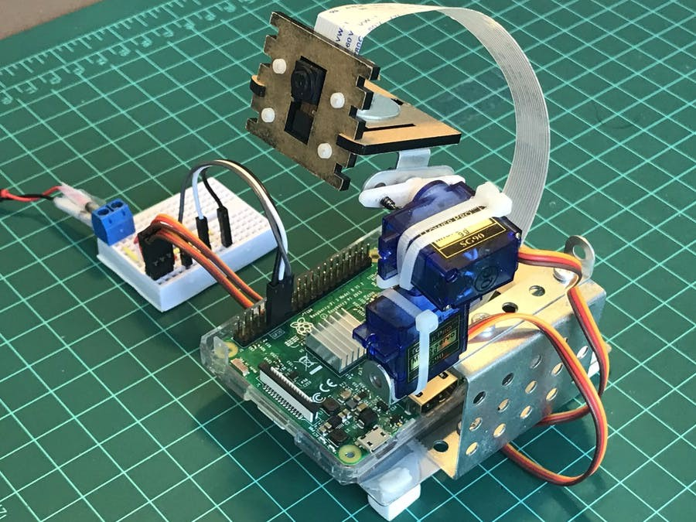

The below code is the function set Servo Angle (servo, angle). This function recives as arguments, a servo GPIO number, and an angle value to where the servo must be positioned.

from time import sleep

import RPi.GPIO as GPIO

GPIO.setmode(GPIO.BCM)

GPIO.setwarnings(False)

def setServoAngle(servo, angle):

pwm = GPIO.PWM(servo, 50)

pwm.start(8)

dutyCycle = angle / 18. + 3.

pwm.ChangeDutyCycle(dutyCycle)

sleep(0.3)

pwm.stop()

if __name__ == '__main__':

import sys

servo = int(sys.argv[1])

GPIO.setup(servo, GPIO.OUT)

setServoAngle(servo, int(sys.argv[2]))

GPIO.cleanup()

**CHAPTER 5**

**RESULTS AND DISCUSSIONS**

After tracking moving object we calculated time Per Frame of video than with the help of centroid of moving object and reference point we calculate distance of moving object .we also calculate velocity and acceleration of moving object .whenever man is moving it will detect and track than we calculated centroid using matlab command. like velocity and acceleration.

**CONCLUSION**

we present a literature survey of object tracking approaches and also give a brief review of related topics. We divide the tracking approaches into three categories, contour based, region based and feature based approach. In our survey we have seen that moving tracking is a kind of motion tracking. Tracking object motion is done by object detection and then using tracking strategy. In this paper, we survey the various approaches of object tracking, including feature descriptors and object segmentation technique in video frames and various tracking methodologies. We expect that this survey on moving object tracking in video with rich theoretical details of the tracking methods along with bibliography contents will give valuable contribution to research works on object tracking and encourage new research.

**REFERENCES**

1] D. Serby, E. K. Meier, and L. V. Gool, "Probabilistic Object Tracking Using Multiple Features", IEEE Proc. of International Conf on Pattern Recognition Intelligent Transportation Systems, Vol. 6, pp. 43- 53, 2004.

[2] L. Li, S. Ranganath, H. Weimin, and K. Sengupta, "Framework for Real-Time Behavior Interpretation From Traffic Video", IEEE Tran. On Intelligen Transportation Systems, , Vol. 6, No. 1, pp. 43-53, 2005.

[3] P. Kumar, H. Weimin, I. U. Gu, and Q. Tian, "Statistical Modeling of Complex Backgrounds for Foreground Object Detection", IEEE Trans. On Image Processing, Vol. 13, No. 11, pp. 43-53, November 2004.

[4] Z Zivkovi, "Improving the selection of feature points for tracking", In Pattern Analysis and Applications, vol.7, no. 2, Copyright Springer-Verlag London Limited, 2004.

[5] J. Lou, T. Tan, W. Hu, H. Yang, and S. J. Maybank, "3D Model-Based Vehicle Tracking", IEEE Trans. on Image Processing, Vol. 14, pp. 1561-1569, October 2005.

[6] N Xu, N Ahuja, ‘Object contour tracking using graph cuts based active contours’, International Conference on Image Processing, pp. 277-280 vol.3, 2002.

[7] P Dokladal, R Enficiaud, E. Dejnozkova , ‘Contour-based object tracking with gradient-based contour attraction field’, EEE International Conference on Acoustics, Speech, and Signal Processing (ICASSP '04) ,pp. 17-20, 2004.

|  |
| --- |
|  |
|  |
|  |